A2651-Afr-Mauritania-Dakhlet region- Disc-Annular-6000 BP

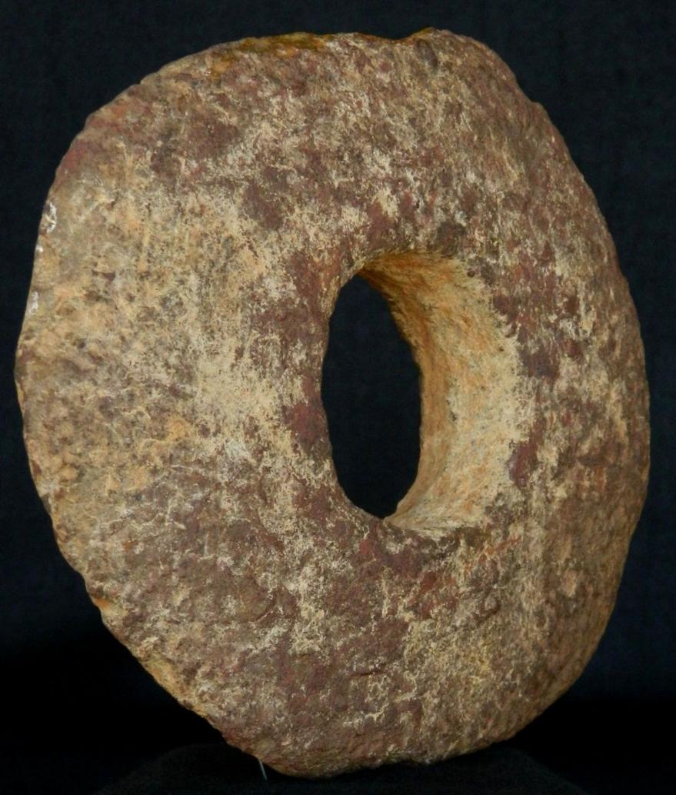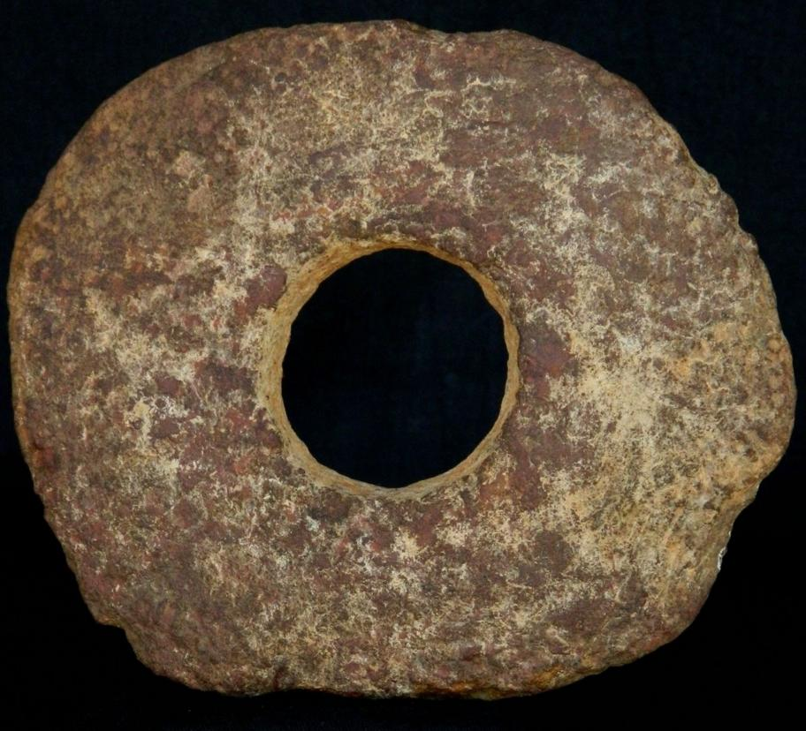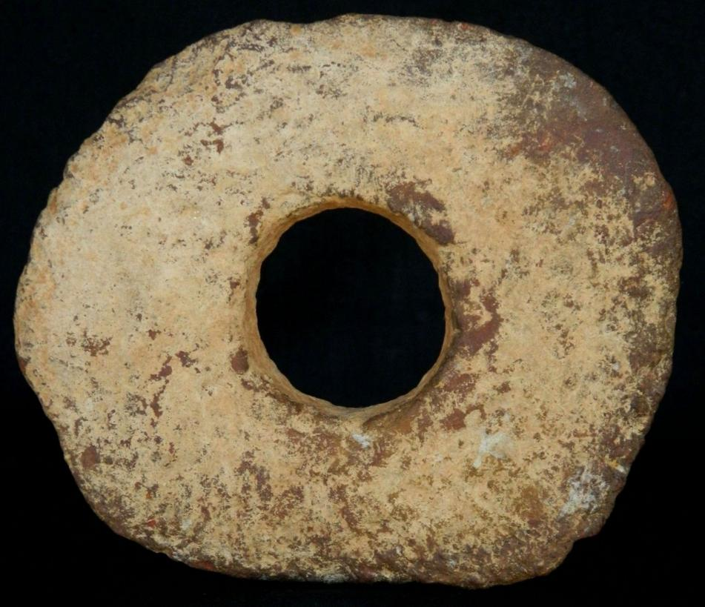 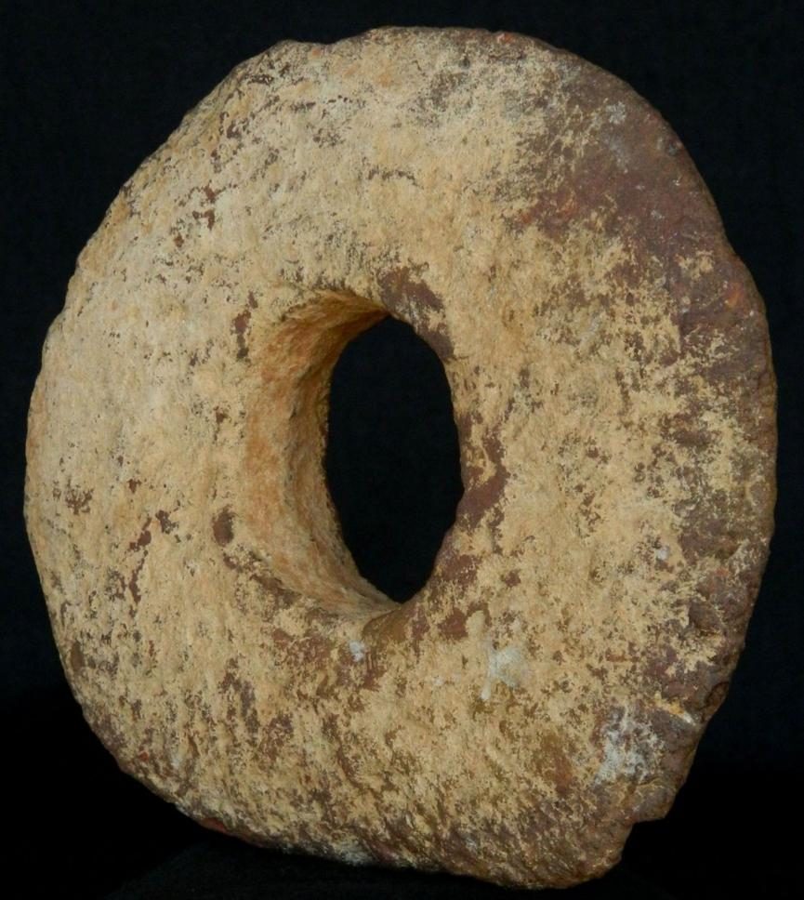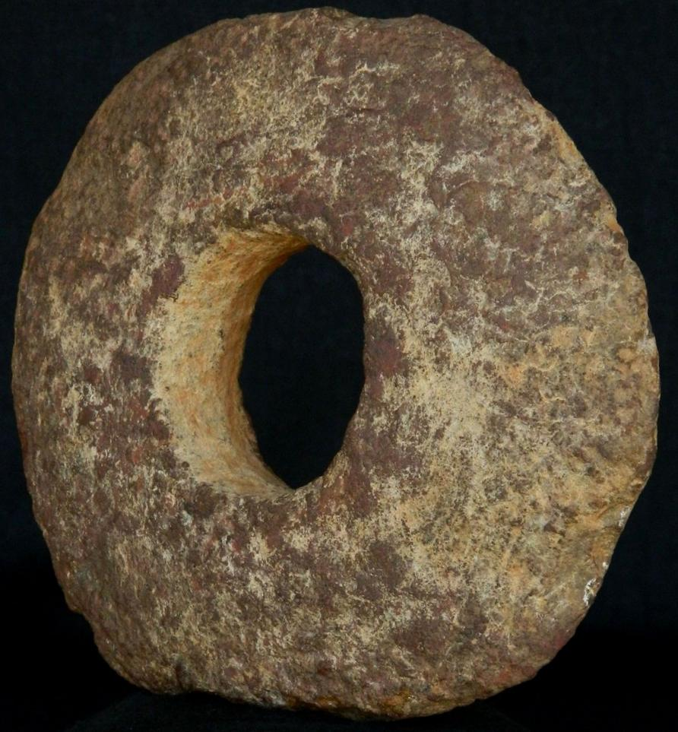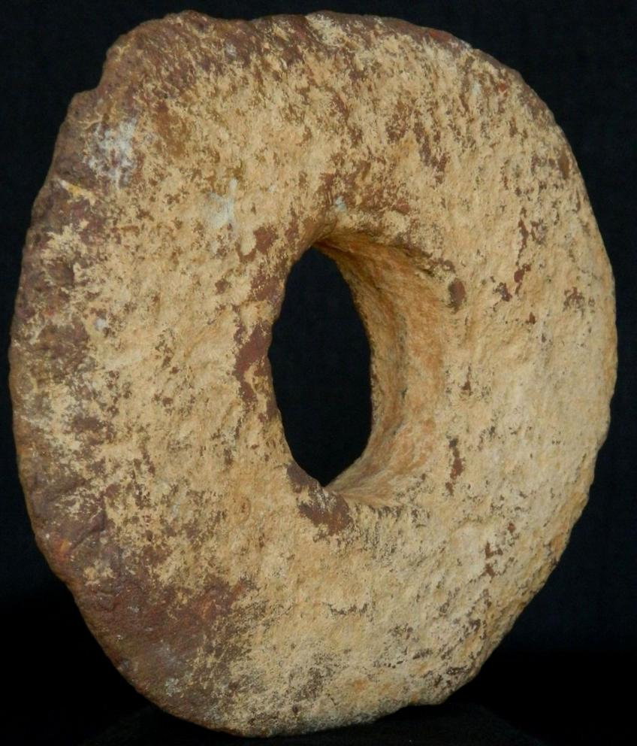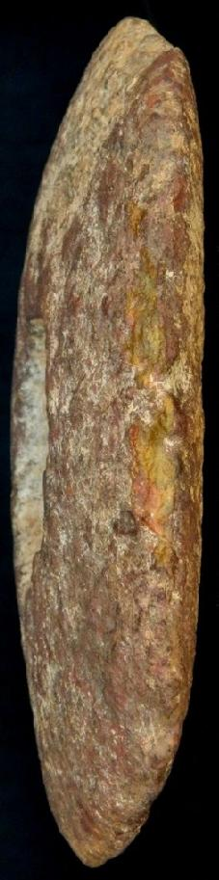

Figs.1-7- Afr-Mauritania-Dakhlet region-Disc-Annular-6000 BP

Case No.:

**Accession No.**

**Formal Label:**

**Display Description:**

Neolithic basalt annular disc-6000 BP-from the Dakhlet region, in the Sahara region of Northern Mauritania

This annular stone was used to improve the fulcrum of the digging stick in dense sandy soil. Although the implement may appear primitive, consider the selection of dense rock with a heavy weight and how practical it was in its desertified environment. These annular discs were essential to digging tubers in hard sandy soil. The use of these “bored stones” was wide-spread throughout Neolithic African areas where tubers could be found by agri-pastoralists. Their initial appearances and origins were probably developed by parallel invention. Such annular discs have been found in Kenya, Tanzania (among the Hadza) to South Africa and from Mauritania to Namibia (among the Damara), Botswana and South Africa (among the Khoikhoi).

**LC Classification:**

**Date or Time Horizon: Neolithic, 6000 BP**

**Geographical Area:**

Dakhlet Messyel Tikifach with the zone of the digging stick extending from Atar to Zouérat to Bir Moghrein.

**Map:**

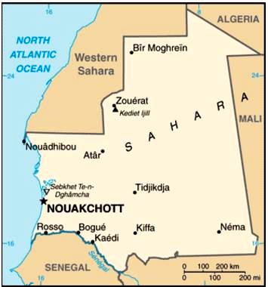

Dakhlet Messyel Tikifach with the zone of the digging stick extending from Atar to Zouérat to Bir Moghrein. From http://cdn.getamap.net/img/maps/country/large/mr-map.gif

**GPS coordinates:**

**Cultural Affiliation: Neolithic**

**Medium: silicified sandstone**

**Dimensions: Dia.** 14 cm / 5.5";- Thickness 2 cm.,

**Weight:**

**Condition: sandblasted by Saharan winds**

**Provenance:**

**Discussion:**

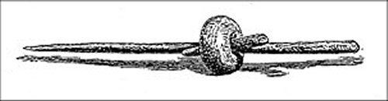

Digging stick with annular disc or bored stone. From the Museum fúr Völkerkunde, Berlin. (Ratzel 1894: 63).



A typical area in northeastern Mauretania where tubers could be dug using the annular disc fitted on a digging stick. From https://encrypted-tbn0.gstatic.com/images?q=tbn:ANd9GcSiqwr0y6tTJTxYLc_6MTgOIs-

**References:**

Ratzel, Friedrich. 1894. Völkerkunde. Volume 1 Leipzig and Vienna.

## Sales order

Sold by [kyramint2001](http://myworld.ebay.com/kyramint2001) ( [1825](http://feedback.ebay.com/ws/eBayISAPI.dll?ViewFeedback&userid=kyramint2001) )

+ Show additional actions

### Delivery package 1 of 1

Estimated delivery Tuesday, Jun 14, 2016 -Thursday, Jun 30, 2016

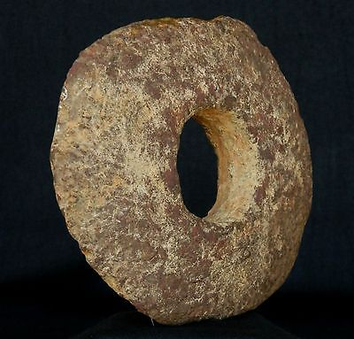

#### [Neolithic Basalt Annular Disc - 14 cm / 5.5"- 6000 to 3000 years BP - Sahara](http://www.ebay.com/itm/301954194597)

|  |  |
| --- | --- |
| **Item price** | $60.00 |
| **Quantity** | 1 |
| **Item number** | 301954194597 |
| **Shipping service** | Economy Shipping from outside US |

[Contact seller](http://contact.ebay.com/ws/eBayISAPI.dll?FindAnswers&frm=3998&iid=301954194597&redirect=0&requested=kyramint2001)

[Return item](https://www.ebay.com/rtn/Return/ReturnViewSelectedItem?transactionId=1261343464020&itemId=301954194597&_trksid=p2057872.m2749.l3185)

## Shipping address

Ralph J Coffman Jr

149 Atlantic Ave

Swampscott MA 01907-2427

United States

## Order total

|  |  |
| --- | --- |
| **Subtotal** | $60.00 |
| **Shipping** | $11.95 |

**Total**

$71.95

[View PayPal transaction](http://payments.ebay.com/ws/eBayISAPI.dll?UnifiedCheckoutSummaryRedirect2PP&itemid=301954194597&transId=1261343464020&buyerorseller=0)

Order placed on

Wednesday, May 25, 2016

Payment method

PayPal

Payment date